Year 7 Science
Chemical Sciences
Separation Techniques - Chromatography and Crystallisation

• Set up the following activities.
• Record your observations for each activity.
• Labelled photographs would be perfect.

Try the following inks.

• Permanent pen - blue, black, red.
• White board marker - blue, black, red, green.
• Food colouring - red, blue, green, pink, yellow.

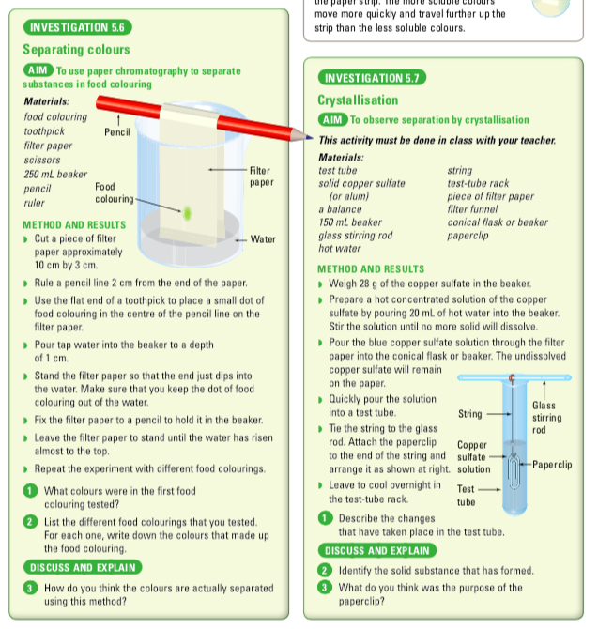
Activity 5.6 - Chromatography

Observations

Question: How do you think the colours are separated?

Activity 5.7 - Crystallisation

Observations

Question: How successful is this technique in recovering the solute?

